Group member:

1. Md Abu Sayed, 80718658
2. Siyu Deng, 80741923

How we find start:

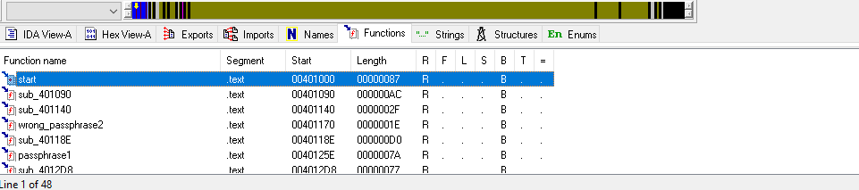

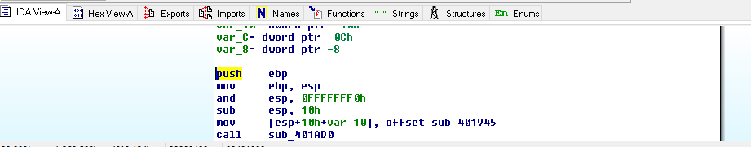

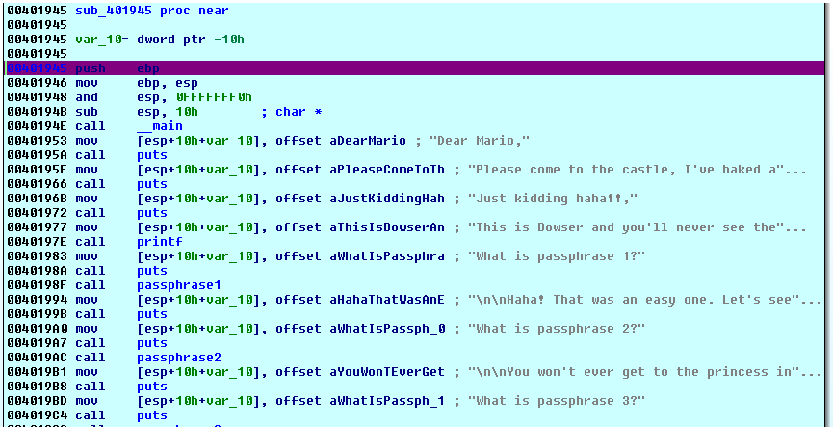

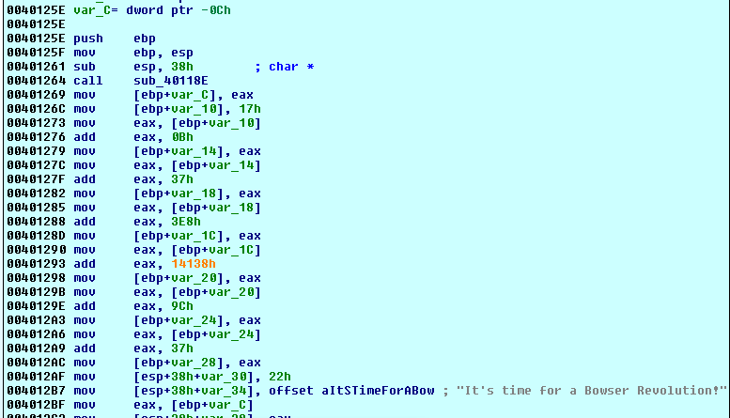

1. Passphrase1: It's time for a Bowser Revolution!
2. After looking at code passphrase2 and initial 4 scanf I realized that 4 local variable is used (var_c, var_10, var_11, var_12).

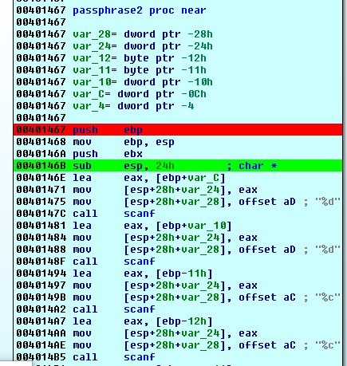

But do not understand how this function takes input. Then look at function and find something important (62h and 64h hex of ‘b’ and ‘d‘).

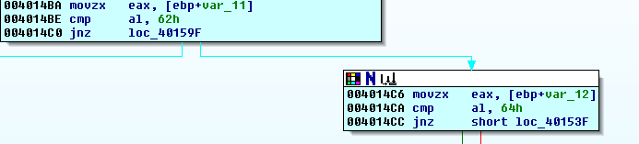

In debug mode try input ‘bd’, then found var_11 and var_12 holds ‘b’ and ‘d’. Then start input number try different input:

12bd: var_c contains 12, var_10 contains nothing, var_11 and var_12 holds ‘b’ and ‘d’

1 2 bd: var_c contains 1, var_10 contains 2, var_11 and var_12 holds space and ‘b’

Finally try 20 10bd it works as input and var_c contains 20, var_10 contains 10, var_11 and var_12 holds ‘b’ and ‘d’. This is very explicit that’s why do not give screenshot.

A lot working 2nd secreet passphrase: **12 2bd, 234 4bd, 11 1br, 21 21br, 32 -10br, 2 22dr, 5 15dn**. I am going to explain how I got each of them.

**12 2bd**: After checking var_11 and var_12 contain ‘b’ and ’d’, code check weather var_c contain 0ch.

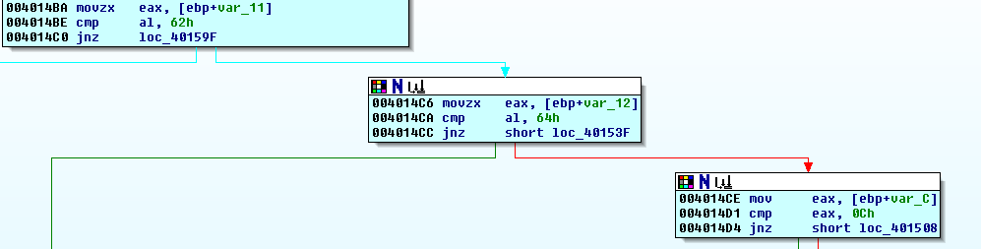

If that’s true then it check var_10 equal to 2(0c % 10 = 2)(this is the meaning of below code). As that match then 12 2bd is valid passphrase.

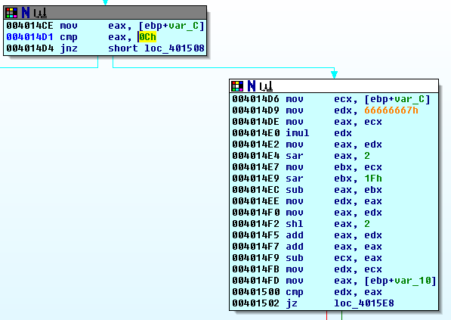

**234 4bd**: This follow the same pattern like previous one. Now var_c = EAh = 234, var_10 must be 4(234 %10 = 4).

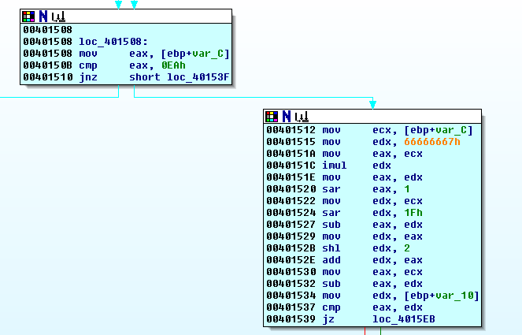

**11 1br**: This follow the same pattern like previous one. Now var_c = Bh = 11, var_10 must be 1(11 %10 = 1). This is for different var_12 value(‘r’)

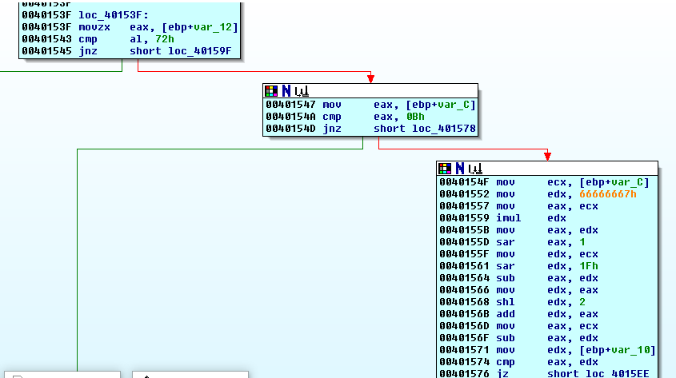

**21 21br**: var_12 is same as previous one(‘r’). var_c = 15h = 21. As directly compare var_c and var_10, so var_10 must be 21.

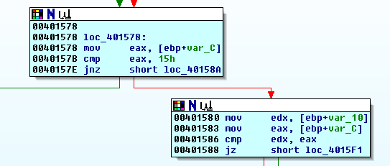

**32 -10br**: var_12 is same as previous one(‘r’). var_c = 20h = 32. As var_c – 42 = 32- 42 = -10, so var_10 must be -10.

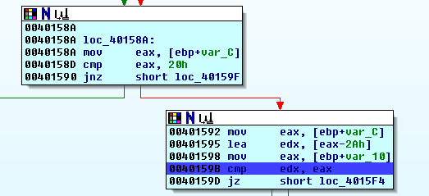

**2 22dr**: var_12 = ‘r’, var_11 = ‘d’ var_c = 2h = 2. var_10 must be var_c + 20 = 2 + 20 = 22.

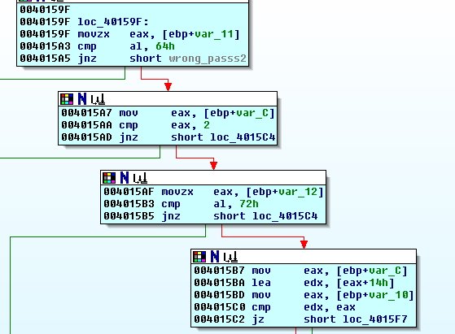

**5 15dn**: var_12 = ‘n’, var_11 = ‘d’, var_c = 5h = 5. var_10 must be var_c + 10 = 5 + 10 = 15.

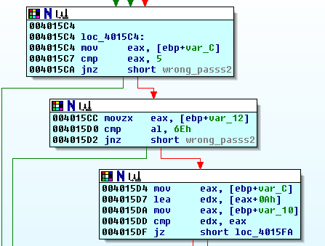

1. Passphrase : **120 35 91 323 1571 10083**

After seeing function passphrase3, I found using loop this function takes 6 numbers input and store them in var_28 variable(size 24 bytes). After completing taking input, function call to sub_40118E(not necessary for finding passphrase3 as it allocates some spaces for 6 numbers that accessed by next Call (sub_4012D8)) and sub_4012D8. Let’s focus on sub_4012D8.

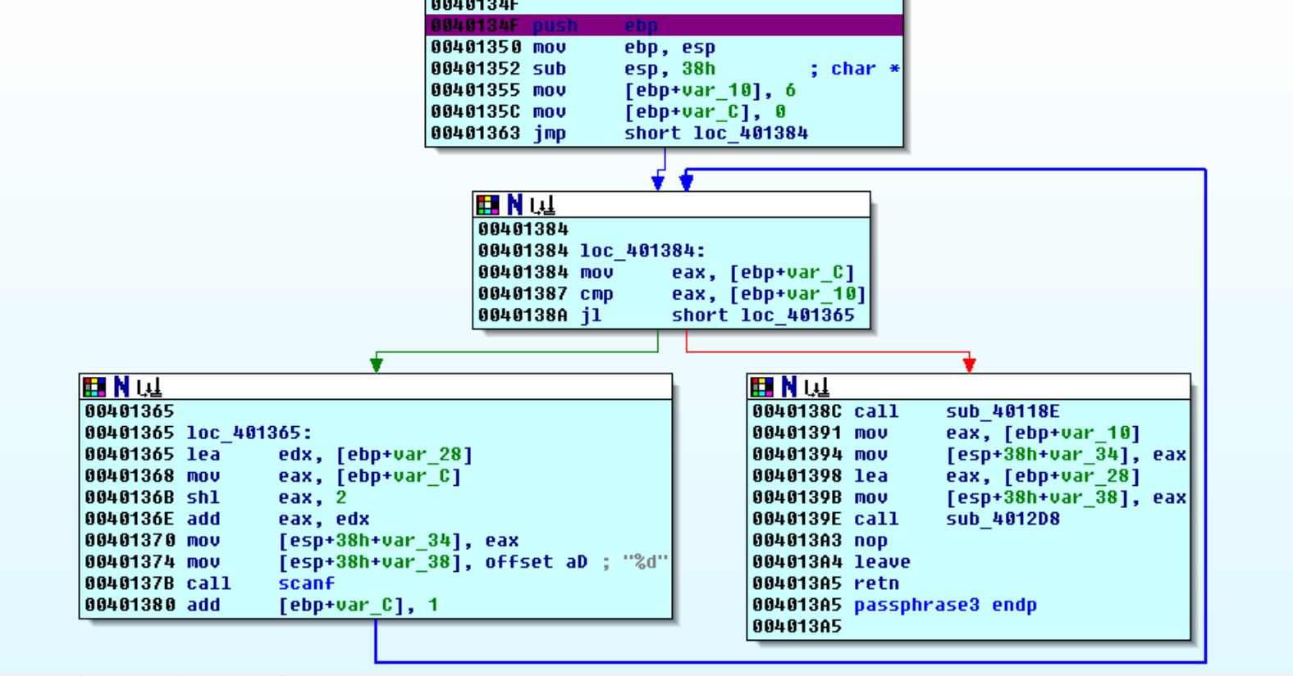

I found first number 78h = 120, by looking at this code, arg_0 holds starting address of var_28, thus eax contain first number and as check eax equal to 120, makes first number must be 120.

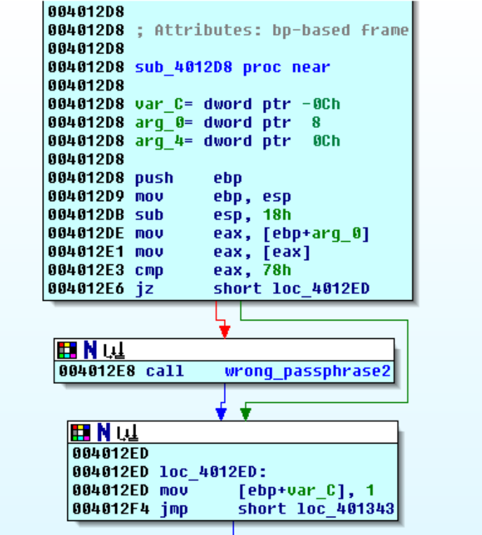

Checking of next number based on below code(loc_4012F6).

var_c = 1

Prev = 120, ecx = calculated number = **35**

Eax = 120 *CCCCCCCDh = , eax = 00000018h, edx = 60h

Edx = 60h = 96 = 48 = 24

Eax = 1 = 0 = 0*24 = 0 = 0 = 0 = 0 +35 = 35(next number)

var_c = 2

Prev = 35, ecx = calculated number = **91**

Eax = 35 *CCCCCCCDh = , eax = 00000007h, edx = 1Ch

Edx = 1Ch = 28 = 14 = 7

Eax = 2 = 1 = 1*7 = 7 = 14 = 28 = 56 +35 = 91(next number)

var_c = 3

Prev = 91, ecx = calculated number = **323**

Eax = 91 *CCCCCCCDh = , eax = CCCCCCDFh, edx = 48h

Edx = 48h = 72 = 36 = 18

Eax = 3 = 2 = 2*18 = 36 = 72 = 144 = 288 +35 = 323(next number)

var_c = 4

Prev = 323, ecx = calculated number = **1571**

Eax = 323 *CCCCCCCDh = , eax = 666666A7h, edx = 102h

Edx = 102h = 258 = 129 = 64

Eax = 4 = 3 = 3*64 = 192 = 384 = 768 = 1536 +35 = 1571(next number)

var_c = 5

Prev = 1571, ecx = calculated number = **10083**

Eax = 1571 *CCCCCCCDh = , eax = CCCCCE07h, edx = 4E8h

Edx = 4E8h = 1256 = 628 = 314

Eax = 5 = 4 = 4*314 = 1256 = 2512 = 5024 = 10048 +35 = 10083(next number)

All numbers: 120 35 91 323 1571 10083

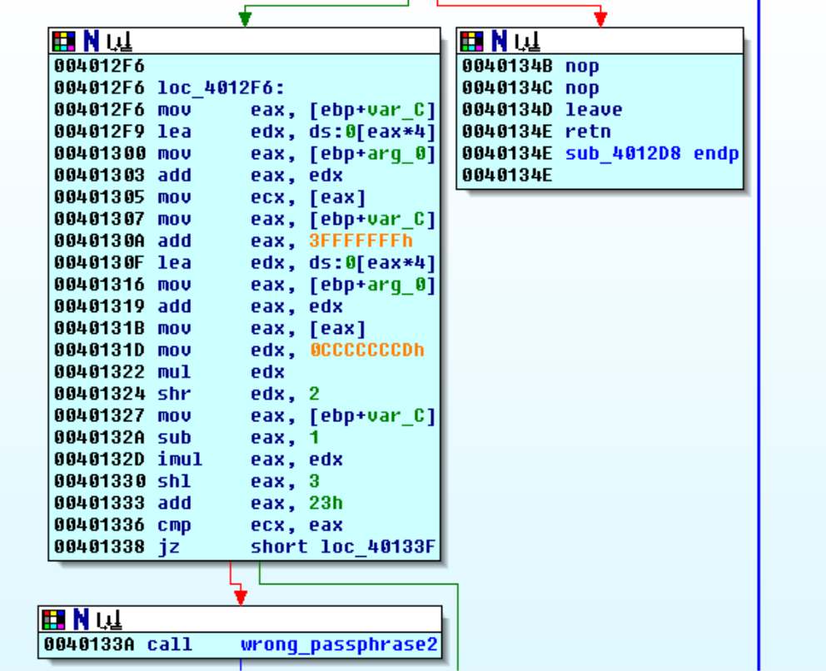

1. No Passphrase. We need to manipulate something. After look into function ‘passphrase4’, we saw it trying to open file ‘bowsers_junk.bin’. But in debug mode, after call _fpopen64, eax value(file pointer) is zero that means can not open that file.

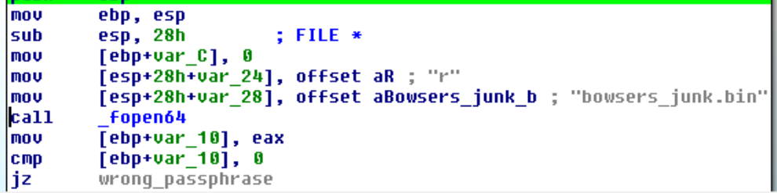

Then we look at string and find a link to download ‘bowsers_junk.bin’ file. we download that file and keep that file in same folder of trigger.exe and it open that file when we run trigger.exe.

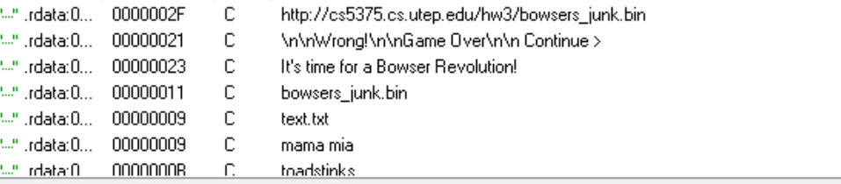

1. Passphrase5 is little bit tricky. We need to manipulate a file that create when exe is running. ‘passphrase5_2_1’ create a ‘text.txt’ file and write ”mama mia”.

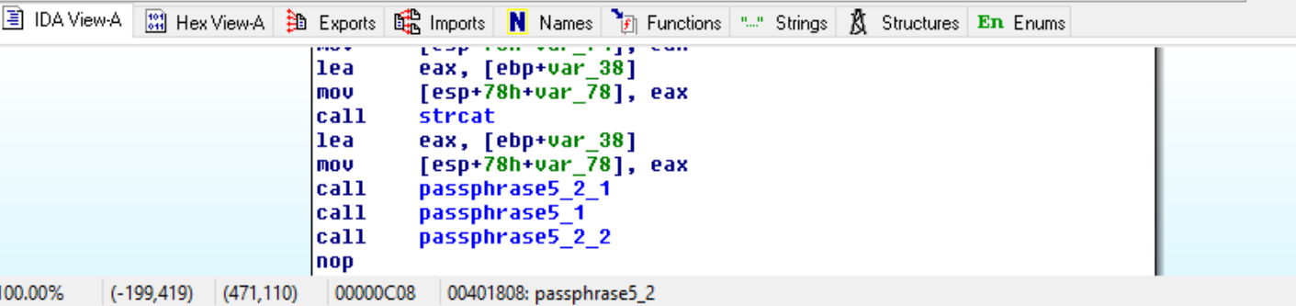

‘passphrase5_2_2’ read “text.txt” upto space and store it to var_10B(“mama”). Then check whether var_10B contains substring “toadstinks”. So if we change ‘text.txt’ content (‘mama’ to ‘toadstinks’) that actually solve passphrase5.

